
DIGITAL INNOVATION LAB

- Name of Principal Investigator/ Group Leader: Dr. Manish Kumar Pandey
- Research Theme: Artificial Intelligence and Digital Transformation
- Broad Area of Research and Scope:
  - AI/ML-Based Solutions in BFSI
  - Data Science and Engineering
  - Quantum Computing
  - Big Data Analytics
  - Climate Change Analytics
  - Intelligent Automation
Schematic Representation of Broad Area of Research:
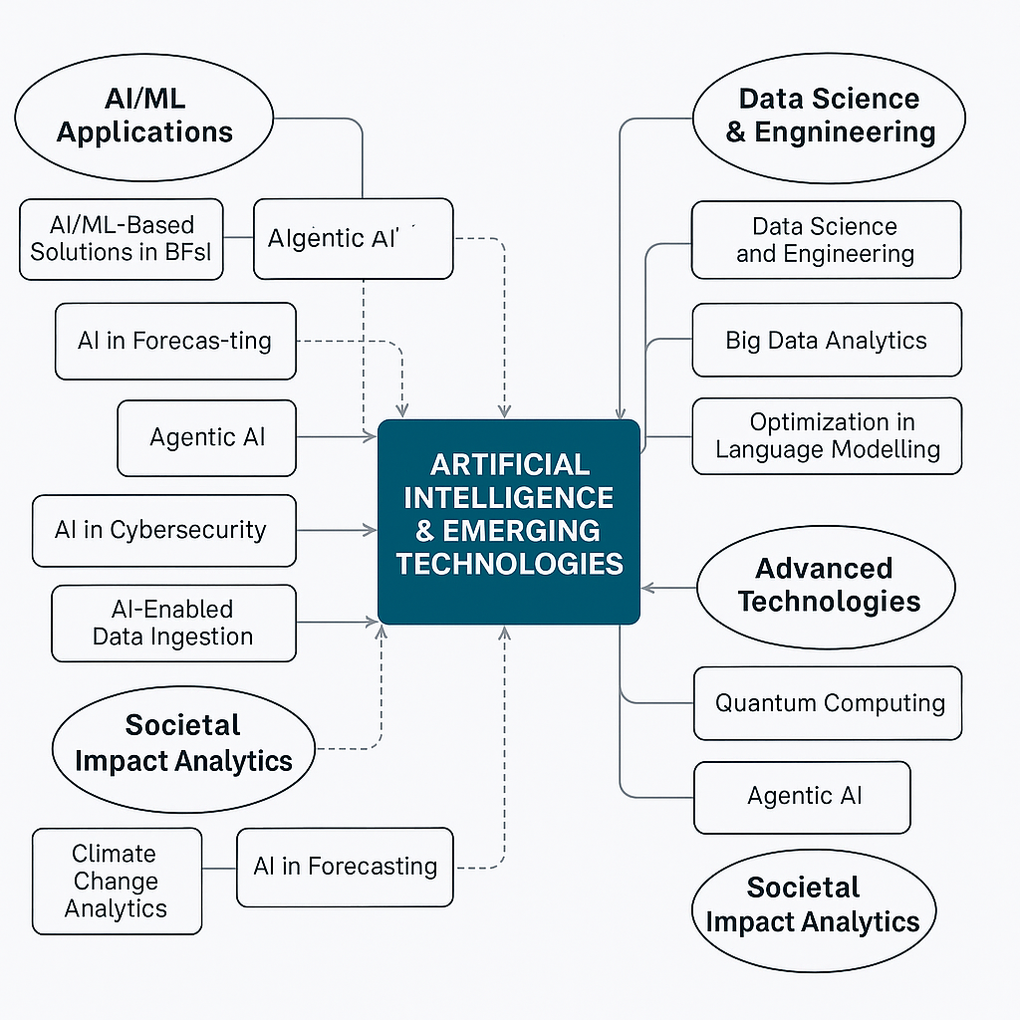
Total Number of Publications by the group:
Top 5 Article with impact factor: (Vancouver Style)
- Surydhwaj P, Kumar Pandey M. AI-Insurance Unleashed: Redefining Insurance using Language Models. Whitepaper.
- Sharma N, Kumar Pandey M. Integrative approaches for skin cancer detection and classification: a dual modal analysis. Accepted for presentation at: International Conference on Artificial Intelligence and Computer Vision in Medical Domain (AICVMD-2025); 2025 Feb 17–19; Banaras Hindu University.
- Sharma N, Kumar Pandey M. Classification and identification of malware families using deep learning techniques. Accepted for presentation at: 2nd Annual QEDS Conference (AACM-2025); 2025 Feb 13–15; Birla Institute of Technology.
- Surydhwaj P, Kumar Pandey M. Explainability of encoder-based LLMs in medical text classification. Accepted for presentation at: International Conference on Communication and Smart Device (ICCoSD 2025); 2025 Jul 25–27; Birla Institute of Technology. DOI: 10.1109/ICCoSD66074.2025.11348575

- Patents by the group: NA
Research Projects: Recent 5 in chronological
Title | Role  (PI/ Co-PI) | Funding Agency | Amount  (in Lacs) | Duration
Digital Innovation Lab | PI (Head) | Adrosonic IT Consultancy Pvt Ltd. | INR 92,63,523.92 | 1st March 2023 to 28th February 2028

Industry/Academia Collaborations:
No. of Active International Collaborations (in terms of Research, Publication etc.):
- NASA Jet Propulsion Laboratory
- Umeå University, Umea, Sweden
- Systems Engineering and Automatic Control, University of the Basque Country
- Higher School of Saharan Agriculture Adrar (Algeria)
- USTHB (Algeria) & Aber. Univ. (UK)
- Aarhus University; Department of Geography, Harokopio University, Athens, Greece
- Informatics Centre, School of Science and Technologies, University of Camerino, 62032 Camerino, Italy
- Clinical Research Centre, School of Medicinal and Health Products Science, University of Camerino, Camerino, Italy
- KTH Engineering Mechanics, Stockholm (Sweden); Louisina State University
- International Rice Research Institute, India
No. of National Level Collaborations (in terms of Research, Publication etc.):
- Defense Terrain Research Laboratory (DTRL) DRDO
- IESD BHU
- Delhi University
- University of Allahabad
- National Institute of Advanced Studies, Bangalore
- Indian Institute of Science, Bangalore
- IARI, New Delhi
- Space Applications Centre, ISRO Ahmedabad
- CSRE-IIT,
- SNU New Delhi
- Rani Lakhsmi Bai Agricultural University, Jhansi

No. of Industrial Collaboration (Research Publication/Consultancy etc.)
- Adrosonic IT Consultancy Pvt Ltd., State Bank of India, Fractal Analytics, TCS and Adani Group
Targeted Application Area:
  - AI in forecasting
  - AI enabled Data Ingestion
  - Agentic AI
  - AI in Cybersecurity
  - Intelligent Object Identification
  - Optimization in Language Modelling
Achievements:
- Travel Support from Adrosonic London, UK to showcase the Digital Innovation Lab prototypes at Elevate Connect.
- Participation in the Panel Discussion on AI’s Impact on Art & Literature in Metaphor- Lucknow Literature Festival on 14th December 2024 at CII, Vibhuti Khand, Gomtinagar, Lucknow.
Brief Description of Projects : To explore the Multimodality and Explainability in Large Language Models (LLMs) for the insurance industry.

Applications:
- AI enabled BFSI Domain
- Customer support
- Multi-modal claim processing
- Fraud detection
- Responsible AI in Insurance

Problem Statement:
The fusion of multimodality in Large Language Models (LLMs) is an exciting and rapidly evolving area of research. It involves integrating multiple types of data (e.g., text, images, audio, video) within LLMs to create models that can understand and generate more comprehensive and contextually rich information. Explainable AI (XAI) in Large Language Models (LLMs) is an emerging area of research focused on making the decisions and behaviors of these complex models understandable to humans. LLMs, such as GPT-4, are powerful tools for generating text and performing various natural language processing tasks, but their inner workings and decision-making processes are often opaque, leading to a "black box" problem. Explainable AI aims to address this by providing insights into how these models make predictions, which is crucial for building trust, ensuring fairness, and enabling safe deployment in critical applications.

Strategy/ Approach/ Technique/ Experiments used to solve
- Methods like LIME (Local Interpretable Model-agnostic Explanations) and SHAP (SHapley Additive exPlanations) can be adapted to LLMs to highlight influential words or phrases that led to the model's response.
- Methods like LIME (Local Interpretable Model-agnostic Explanations) and SHAP (SHapley Additive exPlanations) can be adapted to LLMs to highlight influential words or phrases that led to the model's response.

Group Members:
