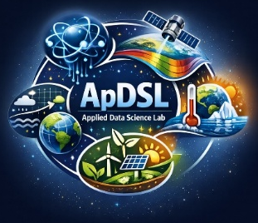
APPLIED DATA SCIENCE LAB
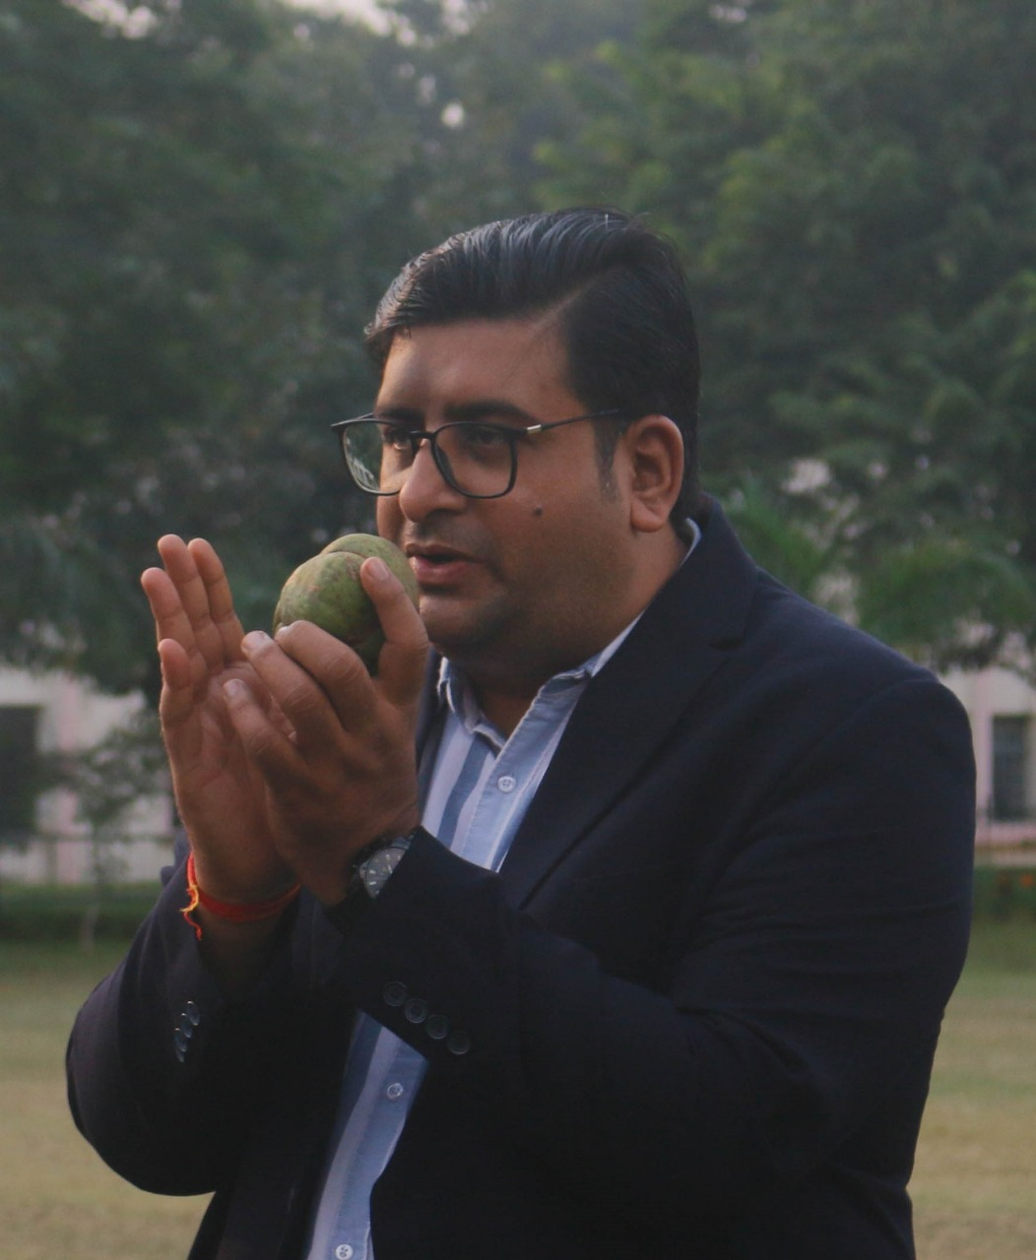
- Name of Principal Investigator/ Group Leader: Dr. Manish K Pandey

- Research Theme: Quantum Computing, Hyperspectral Analytics, Climate
Change Analytics, Data Assimilation, Sustainability Solutions.

- Broad Area of Research and Scope:
- Quantum Computing
Quantum computing harnesses the principles of quantum mechanics to solve complex problems beyond the capability of classical computers. It holds transformative potential for cryptography, optimisation, and scientific simulations.
- Hyperspectral Analytics
Hyperspectral analytics involves analysing data across hundreds of spectral bands to detect subtle differences in materials. It is widely used in agriculture, mineralogy, and environmental monitoring.
- Climate Change Analytics
Climate change analytics uses historical and real-time data to model, monitor, and predict climate trends. It supports evidence-based policy making and risk mitigation strategies.
- Data Assimilation
Data assimilation integrates observational data with model forecasts to improve accuracy in environmental and climate systems. It enhances predictive power in weather forecasting, oceanography, and hydrology.
- Sustainability Solutions
Sustainability solutions focus on developing technologies and strategies that meet present needs without compromising future generations. These include renewable energy, resource efficiency, and resilient ecosystems.

Schematic Representation of Broad Area of Research:
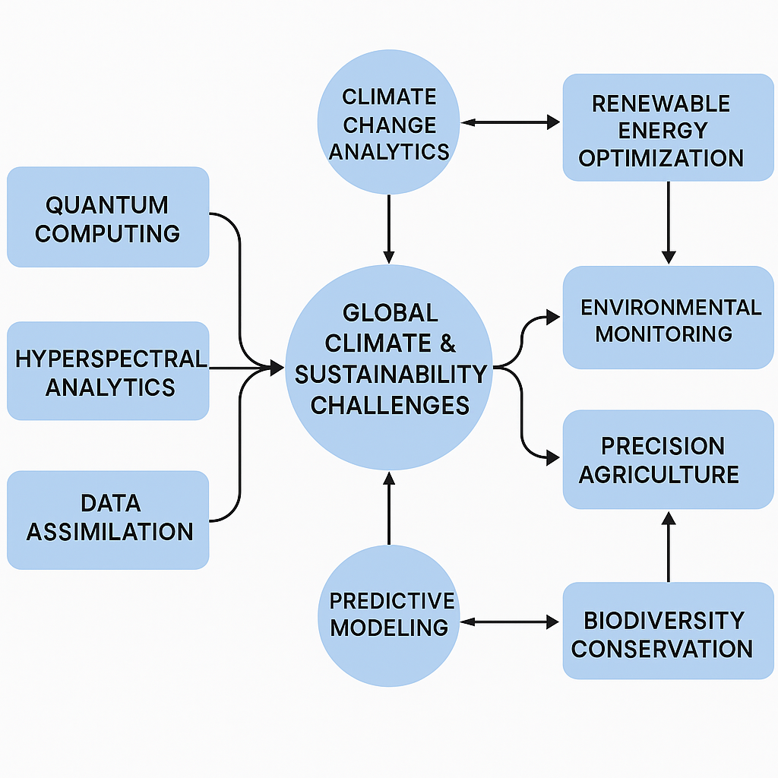

Top 5 Article with impact factor: (Vancouver Style)
- Jaiswal R, Shekhar H, Gupta S, Payra S, Kumar Pandey M, Verma S. Assessing the impact of land use changes on PM2.5 concentrations: A geographically weighted regression approach. In: EGU General Assembly 2024; 2024 Apr 14–19; Vienna, Austria. EGU24-16601. Available from: https://doi.org/10.5194/egusphere-egu24-16601
- Jaiswal R, Shekhar H, Kumar Pandey M, Verma S. Urban growth and air quality: Tracking PM2.5 changes over two decades. In: IEEE International Geoscience and Remote Sensing Symposium (IGARSS) 2025; 2025 Aug 3–8; Brisbane, Australia.
- Neeraj K. Maurya, Manish K. Pandey, Chapter 13 - Application of machine learning in forest monitoring: recent progress and future challenges, Editor(s): Pavan Kumar, Prashant K. Srivastava, Mohammed Latif Khan, Ayyanadar Arunachalam, Parth Sarathi Roy, Kireet Kumar, In Earth Observation, Advanced Geospatial and Ground Based Techniques in Forest Monitoring, Elsevier, 2026, Pages 273-299, ISBN 9780443189494, https://doi.org/10.1016/B978-0-443-18949-4.00006-3
Research Projects: Recent 5 in chronological order
Title | Role  (PI/ Co-PI) | Funding Agency | Amount  (in Lacs) | Duration
- Crop Characterization using Multi-polarization L and S Bands and Biomass Estimation using Novel Deep Learning Algorithms | PI | ISRO | INR 28,47,000.00 | Feb 2026 to Jan 2029
- Development of a Robust Machine Learning Tool to Support Quick Malaria Detection and Parasite Stage Identification for Reducing Malaria Burden | Co-PI | ICMR | 151.50 | Feb 2025 to January 2028
- One-day national workshop on “data analytics for efficient decision-making” in collaboration with the Administrative Staff College of India, Hyderabad | Convener | ASCI |  | 7 January 2024
- Quantum Machine Learning for Hyperspectral Medical Image Processing | Supervisor | I-HUB QUANTUM TECHNOLOGY FOUNDATION, IISER | 0.5 | 1st February 2024 to 30th June 2024
- 4 weeks Training and Skill Internship (VRITIKA) on “Hyperspectral Data Analytics” | Event Organizer | Science and Engineering Research Board (SERB) | 1.5
- Microwave satellite data assimilation in Weather Research & Forecasting model through deep learning for improved forecasting of surface and sub-surface soil moisture conditions | Co-PI | SERB | 25.41 | March 2023 to February 2026
- Development and Validation of Graph Optimisation-Based Multi-Sensor Fusion Algorithm to Establish Real-Time Connections between Climatic Variables in Himalayan Ecohydrological Process Networks for Future Climate Projections. | PI | BIT Mesra  (SEED Money Scheme) | 5 | September 2022 to August 2024
- High-End workshop (KARYASHALA) on “Techniques and Applications of Hyperspectral Data Analytics” | Event Organizer | Science and Engineering Research Board (SERB) | 5 | 25th July to 7th August 2022

Industry/Academia Collaborations:
No. of Active International Collaborations (in terms of Research, Publication etc.):
- NASA Jet Propulsion Laboratory
- Umeå University, Umea, Sweden
- Systems Engineering and Automatic Control, University of the Basque Country
- Higher School of Saharan Agriculture Adrar (Algeria)
- USTHB (Algeria) & Aber. Univ. (UK)
- Aarhus University; Department of Geography, Harokopio University, Athens, Greece
- Informatics Centre, School of Science and Technologies, University of Camerino, 62032 Camerino, Italy
- Clinical Research Centre, School of Medicinal and Health Products Science, University of Camerino, Camerino, Italy
- KTH Engineering Mechanics, Stockholm (Sweden); Louisina State University
- International Rice Research Institute, India
No. of National Level Collaborations (in terms of Research, Publication etc.):
- Defense Terrain Research Laboratory (DTRL) DRDO
- IESD BHU
- Delhi University
- University of Allahabad
- National Institute of Advanced Studies, Bangalore
- Indian Institute of Science, Bangalore
- IARI, New Delhi
- Space Applications Centre, ISRO Ahmedabad
- CSRE-IIT,
- SNU New Delhi
- Rani Lakhsmi Bai Agricultural University, Jhansi
No. of Industrial Collaboration (Research Publication/Consultancy etc.)
- Adrosonic IT Consultancy Pvt Ltd., State Bank of India, Fractal Analytics, TCS and Adani Group
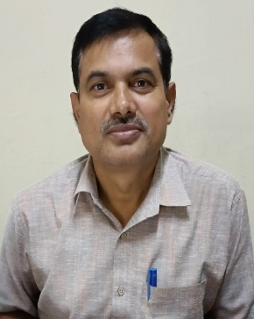
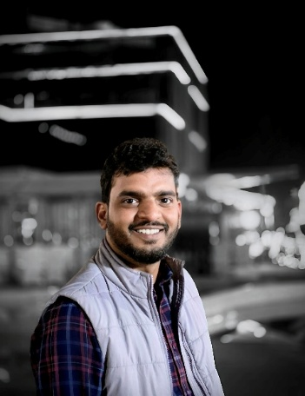
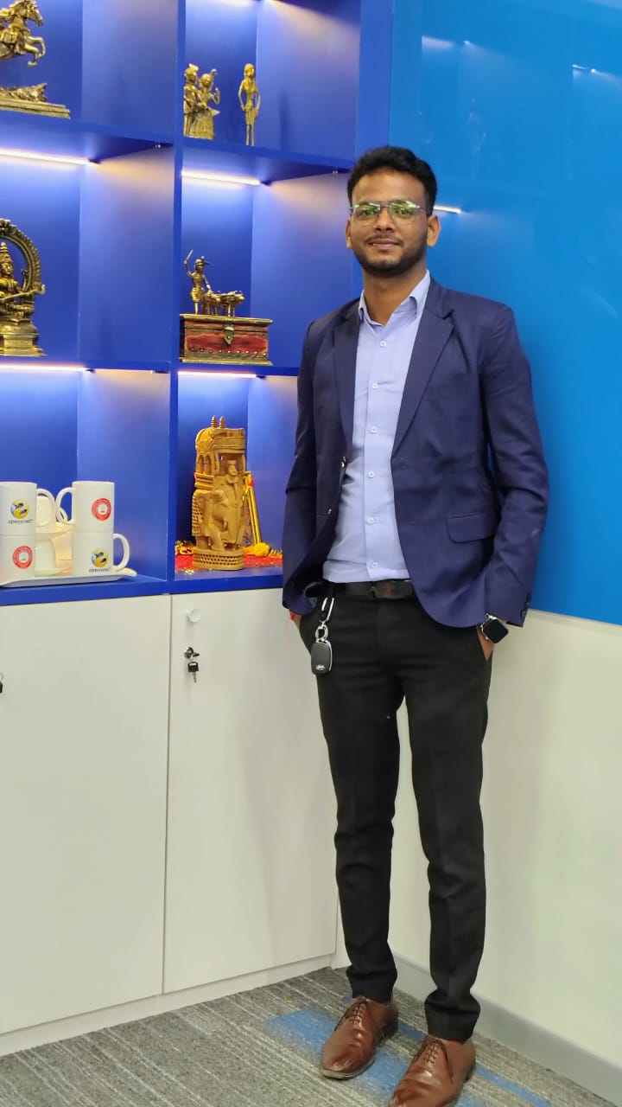
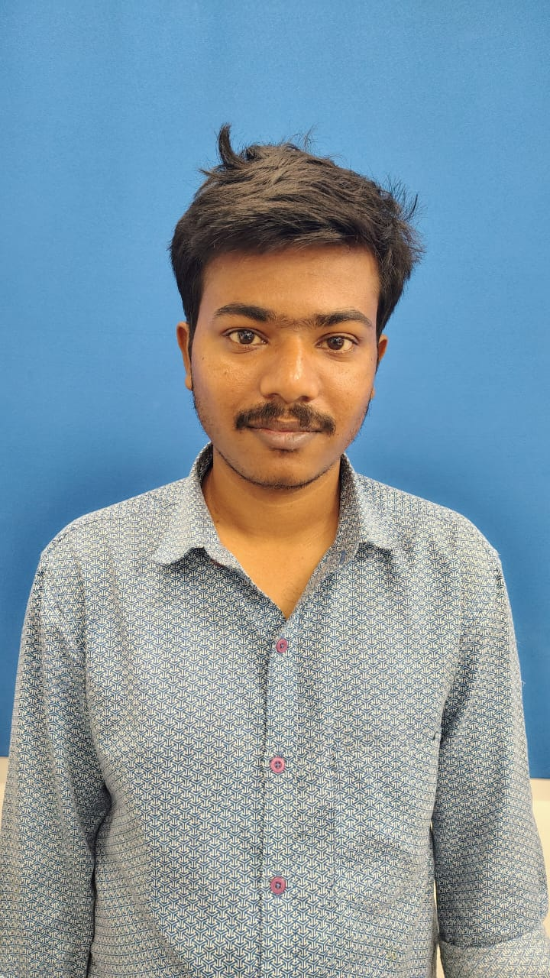
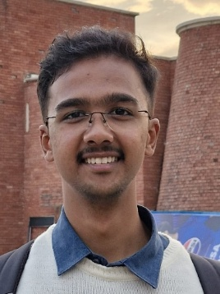
Group Members:

