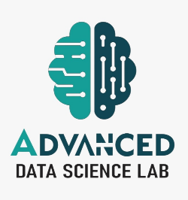
ADVANCED DATA SCIENCE LAB

- Name of Principal Investigator/ Group Leader: Dr. Manish Kumar Pandey
- Research Theme:
- State Bank of India sponsors this Lab for Solving Challenges in Responsible Banking, Risk Governance through Data Driven Approach.
- Broad Area of Research and Scope:
- Responsible Banking
  - Environmental, Social, and Governance (ESG) aspects Forecasting
  - Empowering Service, Transparency, Ethics, Politeness & Sustainability (STEPS).
- Risk Governance
  - Credit Risk, Market Risk, Operational Risk and Liquidity Risk
  - Credit Risk Management, Market Risk Management, Compliance Risk
- Management & ESG Risk Management
  - Analyzing regional and global financial activities, behaviors, events and their impact and risk
Schematic Representation of Broad Area of Research:
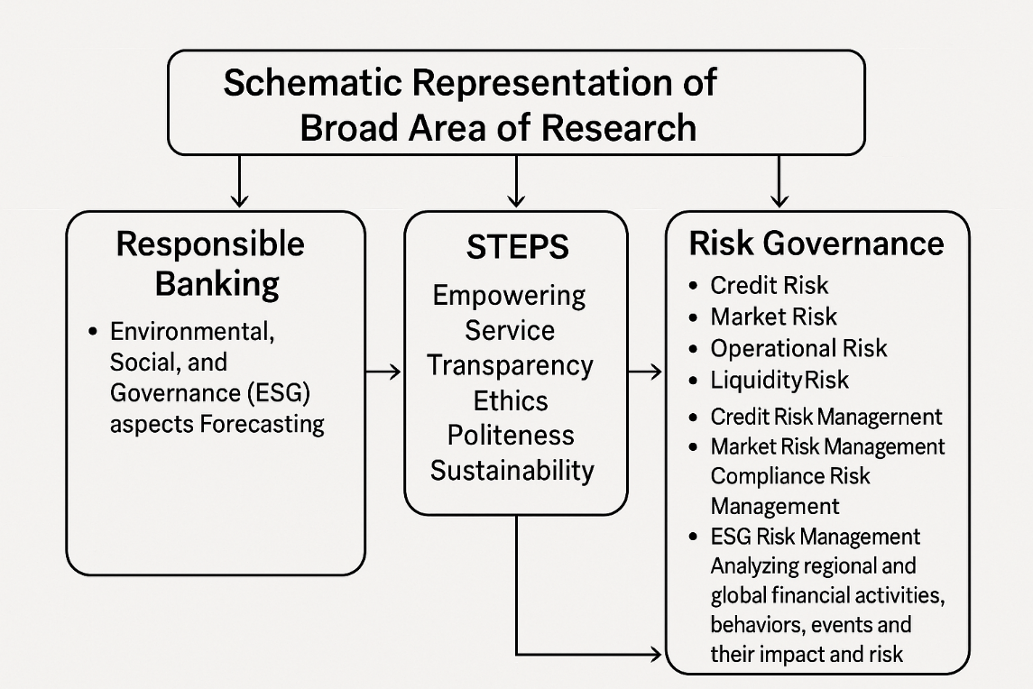

Total Number of Publications by the group:
Top 5 Article with impact factor:
- Kumar Pandey M*, Karthikeyan S. Enhancing financial services sustainability through improved predictive and preventive analytic techniques on defaults made by customers using an optimally balanced dataset. In: 2nd Annual QEDS Conference; 2025 Feb 13–15; Accepted at AACM-2025.
- Mahto B, Kumar Pandey M*. Vision Transformer-driven brain tumor identification with local interpretable model explanations. In: International Conference on Communication and Smart Device (ICCoSD 2025); 2025 Jul 25–27; DOI: 10.1109/ICCoSD66074.2025.11348607.
Research Projects:
Title | Role  (PI/ Co-PI) | Funding Agency | Amount  (in Lacs) | Duration
Development of Machine Learning Tool for Reducing Exposure to  ESG (Environmental, Social, and Governance) Risks | PI | Asha & Sajjan Agarwal Foundation | INR 17,91,000.00 | July 2025 to June 2027
AI-Driven Bamboo Value Chain Optimisation for Sustainable Development and Inclusive Growth in Jharkhand | Co-PI | JCSTI Sponsored | INR INR 4,40,000.00 | Feb 2026 to Jan 2029

Industry/Academia Collaborations:
No. of Active International Collaborations (in terms of Research, Publication etc.):
- NASA Jet Propulsion Laboratory
- Umeå University, Umea, Sweden
- Systems Engineering and Automatic Control, University of the Basque Country
- Higher School of Saharan Agriculture Adrar (Algeria)
- USTHB (Algeria) & Aber. Univ. (UK)
- Aarhus University; Department of Geography, Harokopio University, Athens, Greece
- Informatics Centre, School of Science and Technologies, University of Camerino, 62032 Camerino, Italy
- Clinical Research Centre, School of Medicinal and Health Products Science, University of Camerino, Camerino, Italy
- KTH Engineering Mechanics, Stockholm (Sweden); Louisina State University
- International Rice Research Institute, India
No. of National Level Collaborations (in terms of Research, Publication etc.):
- Defense Terrain Research Laboratory (DTRL) DRDO
- IESD BHU
- Delhi University
- University of Allahabad
- National Institute of Advanced Studies, Bangalore
- Indian Institute of Science, Bangalore
- IARI, New Delhi
- Space Applications Centre, ISRO Ahmedabad
- CSRE-IIT,
- SNU New Delhi
- Rani Lakhsmi Bai Agricultural University, Jhansi

No. of Industrial Collaboration (Research Publication/Consultancy etc.)
- Adrosonic IT Consultancy Pvt Ltd., State Bank of India, Fractal Analytics, TCS and Adani Group
Project:
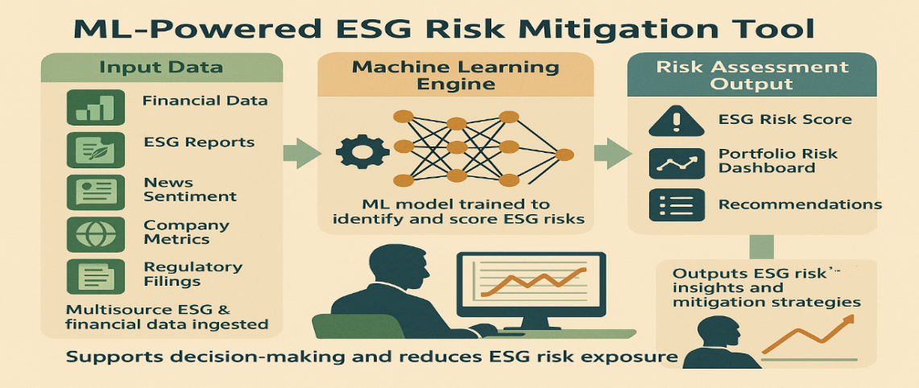
Group Members:
 |  | 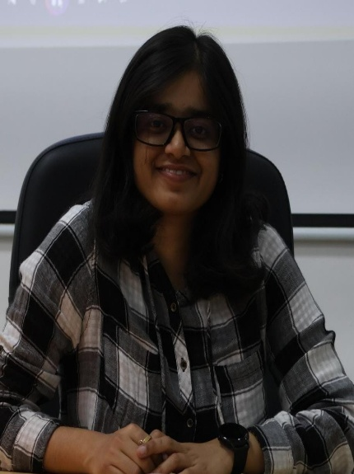
 |  | 

